3 Result

3.1 Demographic Distribution of Participants

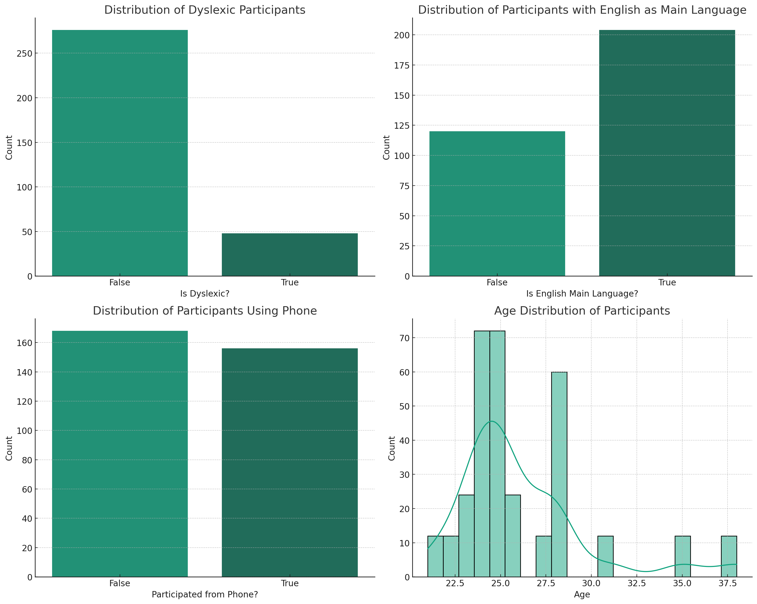

The experiment enlisted a diverse range of participants. A series of bar charts and histograms illustrate their demographic details:

The first bar chart depicts the distribution of participants based on whether they have dyslexia. The majority of the participants did not have dyslexia, while a smaller fraction (15%) identified as dyslexic.

The second bar chart shows that most of the participants do not have English as their primary language.

The third visualization indicates the device preference among participants. The histogram demonstrates the age distribution of participants, the vast majority of which are under 30 years old.

3.2 Data Visualization

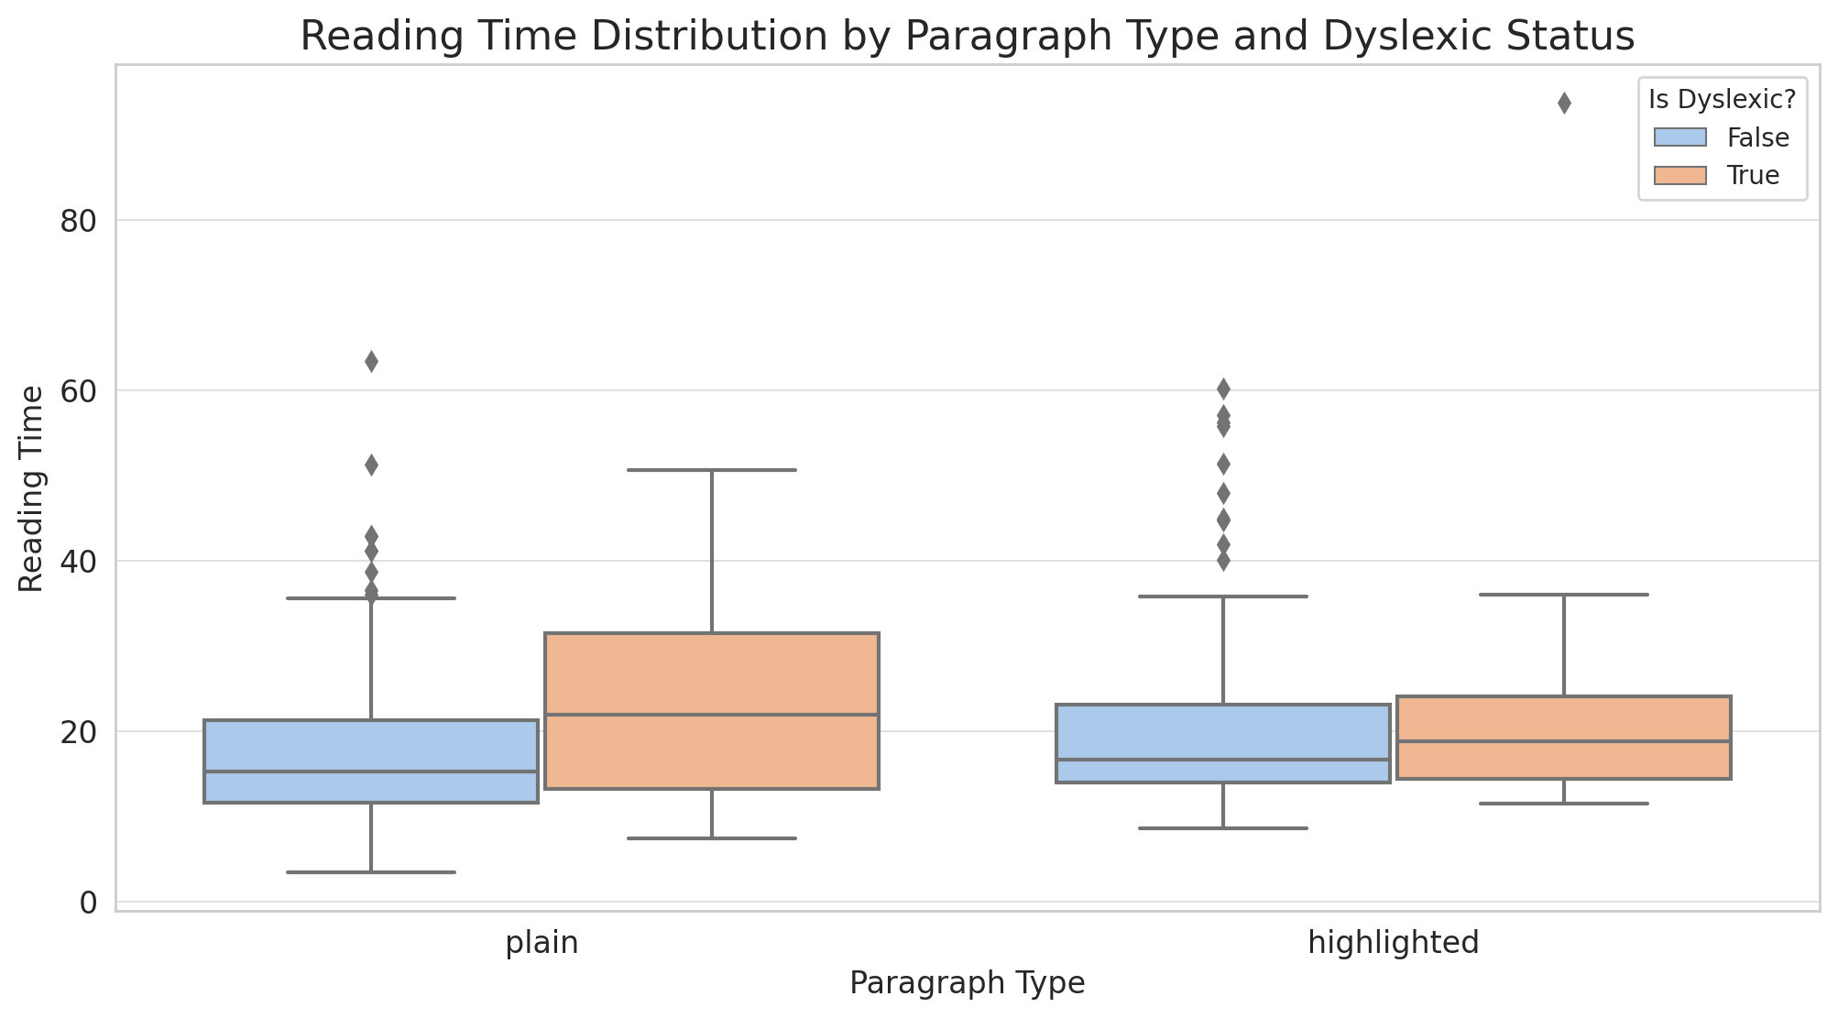

From the boxplot, several observations can be made:

Dyslexic vs Non-dyslexic: dyslexic participants consistently exhibited longer reading times across both paragraph types compared to their non-dyslexic counterparts.

Highlighting Influence: Reading times for highlighted paragraphs appear slightly reduced when compared to the plain paragraph type. However, the difference is minimal.

Presence of outliers: there is a notable trend is the higher occurrence of outliers, particularly among dyslexic participants.

These insights provide an initial understanding of the data distribution, paving the way for the upcoming mixed-effects model analysis.

3.3 LMMs for Reading time

3.3.1 Model Comparison and Selection

Two linear mixed models were compared to determine the best fit for reading time.

Model2(Simplified model without random slopes): This model includes the fixed effects of paragraph type and dyslexic status, their interaction and a random intercept for subjects.

Model1(Complex model with random slopes): This model incorporates random slopes for both paragraph type and dyslexic status within subjects.

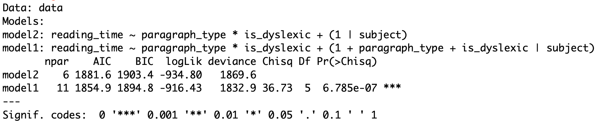

Model comparison results:

Model 2, being more complex has more parameters (11) than Model 1 (6).

Both AIC and BIC are lower for Model 1, indicating a better fit to the data.

Chi-Squared Test: The chi-squared test comparing the two models is significant (p < 0.001), with a value of 36.73 on 5 degrees of freedom. This suggests that the additional complexity in Model 1 provides a significantly better fit to the data.

3.3.2 Detailed Analysis of the Selected Model

Based on the previous model comparison, the more complex model, which includes both fixed effects and their interaction, as well as random slopes for paragraph type and dyslexic status, was selected for further analysis.

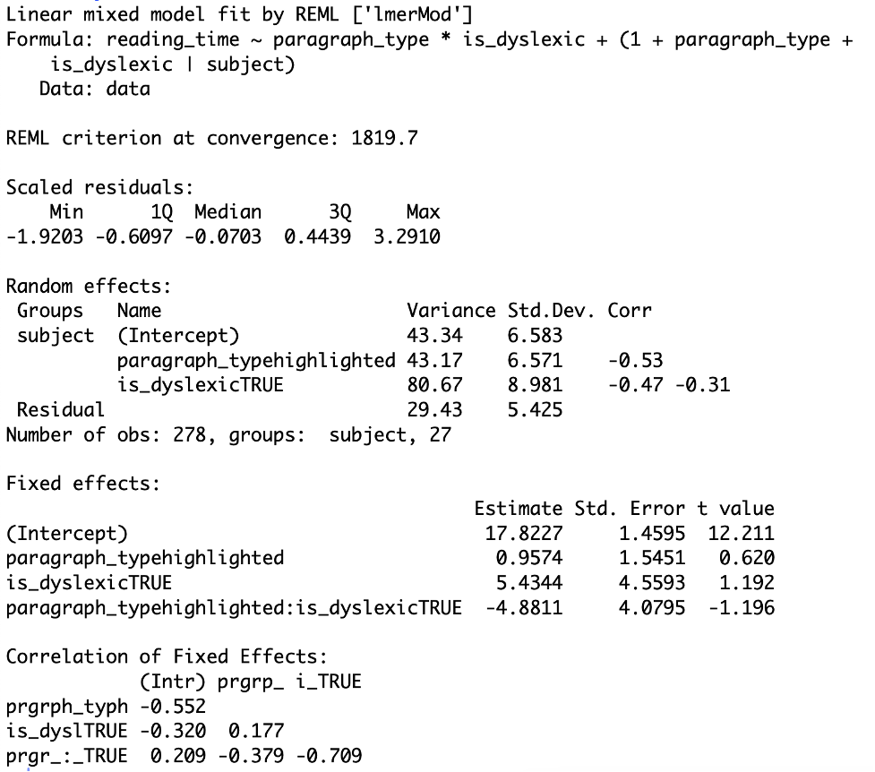

The estimated change in reading time when switching from a plain paragraph to a highlighted paragraph for non-dyslexic participants is an increase of 0.9574 units with SE(1.5451), though this effect is not statistically significant (t = 0.620).

Dyslexic participants reading plain paragraphs have an estimated increase in reading time of 5.4344 units with SE(4.5593) compared to non-dyslexic participants, but this effect is also not statistically significant (t = 1.192).

The interaction of paragraph type (highlighted) and dyslexic status reveals a decrease in reading time by 4.8811 units (t=-1.196, p>0.05).

The selected model emphasizes an interaction effect between paragraph type and dyslexic status. Though individual effects are not statistically significant, their combined influence is notable and warrants further investigation.

3.3.3 Interaction Effect of Paragraph Type and Dyslexia Status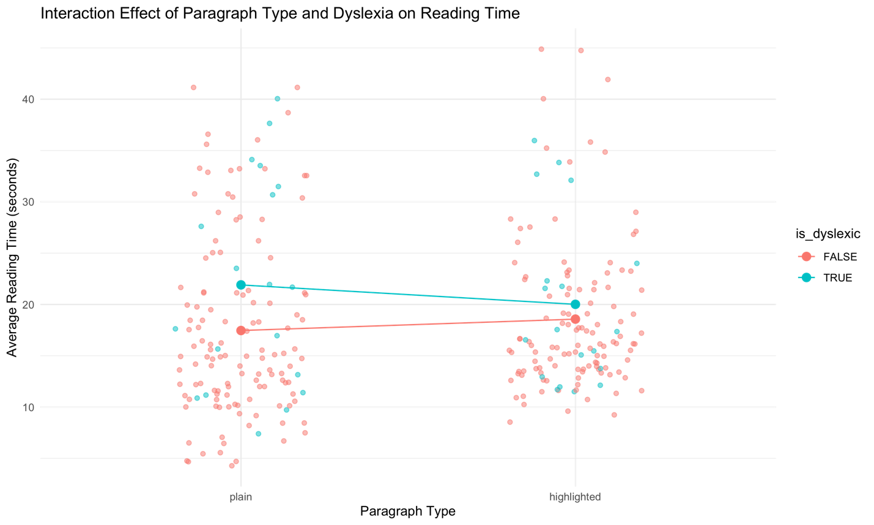

The interaction plot underscores the combined effects of paragraph type and dyslexic on reading time:

Dyslexic participants displayed deduced reading times when moving from plain to highlighted paragraphs.

In contrast, non-dyslexic participants had consistent reading times irrespective of paragraph type.

The discrepancy in reading times between the two paragraph types is more apparent for dyslexic participants.

These insights align with the previous LMM model outcomes.

3.4 GLMM for Accuracy (Error rate)

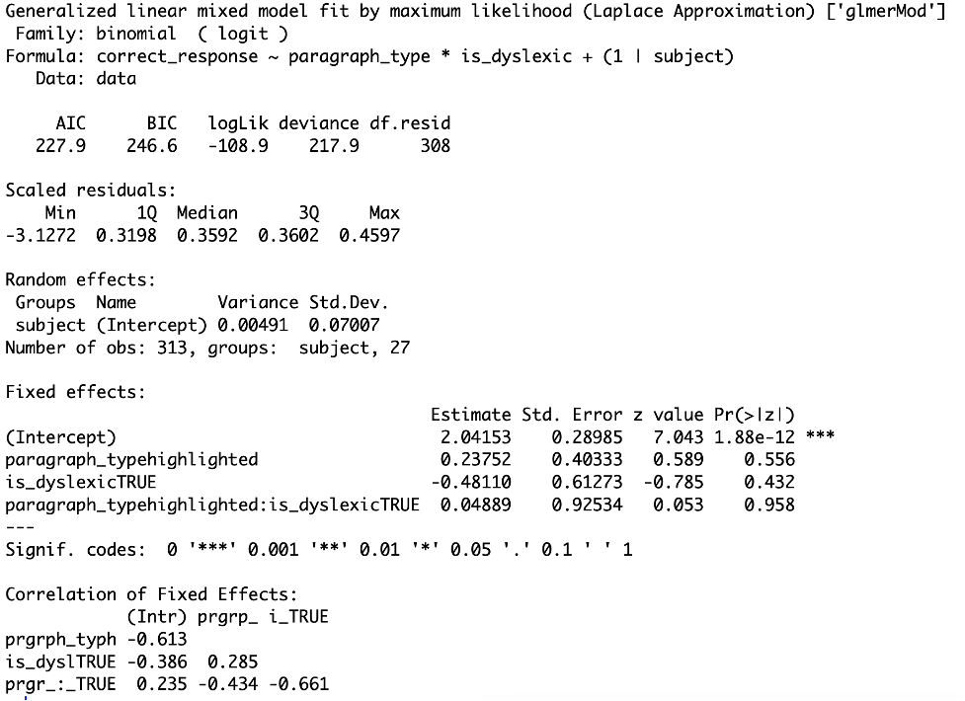

A generalized linear mixed model (GLMM) with a binomial family (logit link) was employed to identify factors influencing participants' accuracy. The model assesses the effects of paragraph type, dyslexic status, and their interaction while accounting for random intercepts for subjects.

Transitioning from a plain to highlighted paragraph resulted in a change in log odds of 0.23752 for non-dyslexic participants (z=0.589, p=0.556).

Dyslexic participants exhibited a decrease in log odds of correct responses by -0.48110 compared to non-dyslexic ones (z=-0.785, p=0.432).

The interaction between paragraph type (highlighted) and dyslexic status yielded a change in log odds of 0.04889 (z=0.053, p=0.958).

Conclusively, the GLMM analysis suggests that neither paragraph type, dyslexic status, nor their interaction significantly influenced correct response likelihood.